**AEM INSTALLATION**

Adobe Experience Manager runs on most operating systems that support the Java platform. All client interactions with Adobe Experience Manager are done through a web browser.

In Adobe Experience Manager terminology, an “instance” is a copy of Adobe Experience Manager running on a server. Adobe Experience Manager installations usually involve at least two instances running on separate computers and a dispatcher:

**Author**

An Adobe Experience Manager instance used to create, upload, and edit content, and administer the website. After content is ready to go live, it is replicated to the Publish Instance.

**Publish**

An Adobe Experience Manager instance that serves the published content to the public.

**Dispatcher**

A static web server (Apache httpd, Microsoft IIS, and so on) augmented with the Adobe Experience Manager Dispatcher module. It caches webpages produced by the Publish instance to improve performance.

NOTE: The author and publish instances are the same software stack but two different run modes.

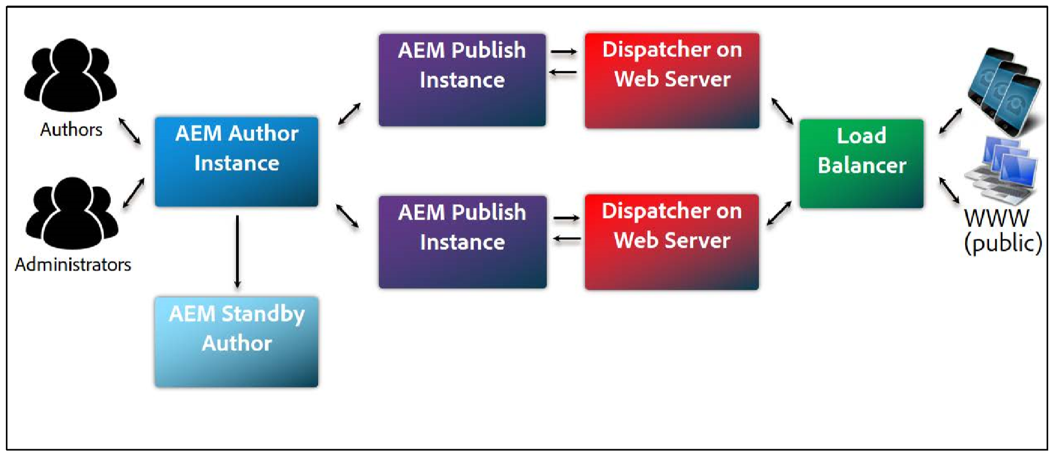

**Installation Prerequisites**

To install Adobe Experience Manager, you need:

1. Adobe Experience Manager installation and startup JAR file
2. A valid Adobe Experience Manager license key properties file
3. JDK version 1.8
4. Approximately 4 GB of free space per instance
5. Approximately 4 GB of RAM (at the very minimum!)

The Adobe Experience Manager installation and startup JAR file is also known as the “quickstart” file. You use the file to install Adobe Experience Manager. Once installed, the file is referred to as the Adobe Experience Manager startup file. During installation, you will notice the JAR file creates a root folder called crx-quickstart.

You also need to set environment variables as a part of your JDK 1.8 setup.

NOTE: You can download the latest JDK version from the following link:

<http://www.oracle.com/technetwork/java/javase/downloads/jdk8-downloads-2133151.html>

**Installing Adobe Experience Manager on Your System**

In general, when you want to install Adobe Experience Manager on your system, you would follow this procedure:

Create two specific folder structures for your Adobe Experience Manager instances:

1. Author instance For Windows: C:/adobe/AEM/author For Mac OS or *x: /opt/adobe/AEM/author OR /Applications/AEM/author
2. Publish instance For Windows: C:/adobe/AEM/publish For Mac OS or *x: /opt/adobe/AEM/publish OR /Applications/AEM/publish Add the AEM Quickstart JAR file along with the license.properties file to each folder which you created earlier.

Rename the jar file to include the run mode as well as the port number. That is, rename the file to the format: aem-<run mode>-<port number>.jar.

For example, Author instance: aem-author-4502 Publish instance: aem-publish-4503 You can therefore control the way Adobe Experience Manager is installed by defining properties via file name.

The first time you double-click the jar file, Adobe Experience Manager will install on your system, creating a root folder called crxquickstart, which serves as your repository.

A sample folder structure for an Author instance is shown below.

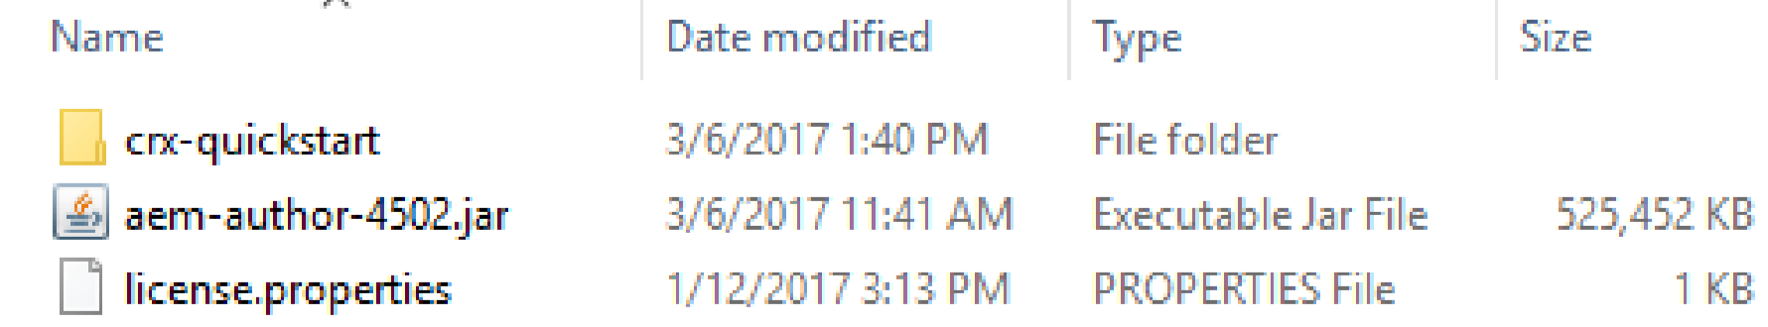

NOTE: The Adobe Experience Manager quickstart file is renamed for installation purposes. When running for the first time, the quickstart file will notice that it has to install Adobe Experience Manager. By renaming the file, you use a convention of passing the instance name (Webpathcontext) and port number through the file name so no user interaction is needed during the installation process. If no port number is provided in the file name, Adobe Experience Manager will select the first available port from the following list in this specific order: 4502, 8080, 8081, 8082, 8083, 8084, or a random port.

NOTE: If you have multiple author and multiple publish instances, a best practice to consider is using an even/odd numbering paradigm for port numbers. So, you author instances would be 4502, 4504, 4506, and so on. Your publish instances would be 4503, 4505, 4507, and so on.

**Starting an Adobe Experience Manager Instance**

There are many ways of starting an Adobe Experience Manager instance, two of which are—graphical and by command line. The latter is more powerful because you have the possibility of providing additional performance-tuning parameters to the Java Virtual Machine (JVM).

Using the *.jar file to Start an Adobe Experience Manager Instance

In a Windows or Mac OS environment, you can double-click the aem-author-4502.jar file to start an Author instance (or the aem-publish4503.jar file for a Publish instance).

Installation will take approximately 5-7 minutes, depending on your system’s capabilities. A dialog window will pop up similar to the following (this is known as the GUI):

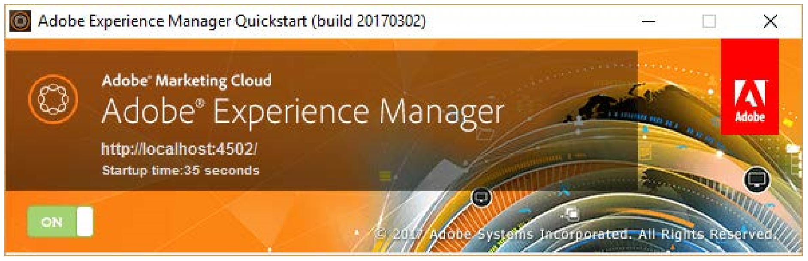

After Adobe Experience Manager starts, your default browser will open automatically, pointing to Adobe Experience Manager’s start URL (where the port number is the one you defined on installation).

**Using the Command Line to Start an Adobe Experience Manager Author Instance**

Prior to the installation, you may want to know which parameters are available to configure quickstart. Enter the following command to display a complete list of optional parameters:

java -jar aem-author-4502.jar -h

The Adobe Experience Manager quickstart installer will show all available command-line options without starting the server. In addition, you need to tune the JVM used for running Adobe Experience Manager. Tuning the JVM is an important and delicate task and requires a more realistic environment in terms of resources (hardware, operating system, and so on) and workload (content, requests, and so on). For now, it will be enough to know that you can start your instance (Author or Publish) using the following parameters:

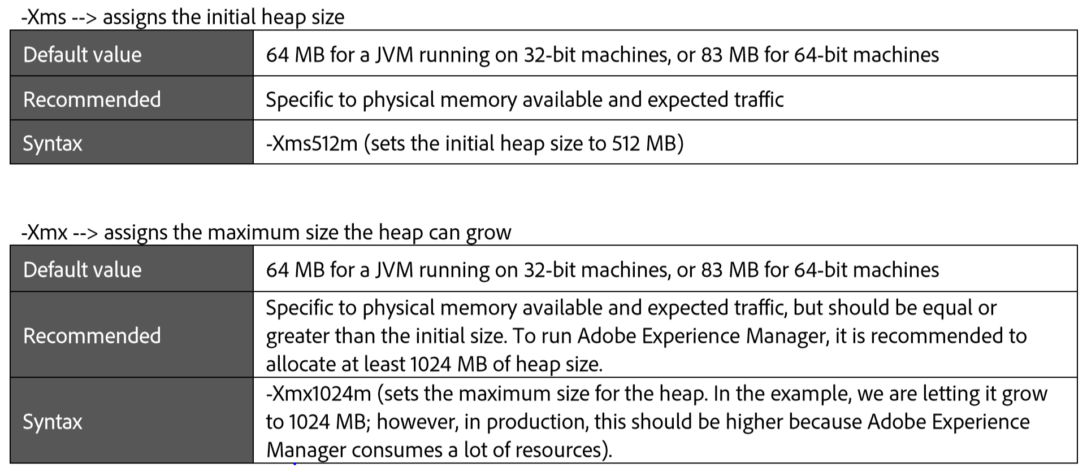

**Recommended**

Specific to physical memory available and expected traffic, but should be equal or greater than the initial size. To run Adobe Experience Manager, it is recommended to allocate at least 1024 MB of heap size.

**Syntax**

-Xmx1024m (sets the maximum size for the heap. In the example, we are letting it grow to 1024 MB; however, in production, this should be higher because Adobe Experience Manager consumes a lot of resources).

You can now install and start Adobe Experience Manager from the command line together with increasing the Java heap size, which will improve performance.

**Using the Command Line to Start Adobe Experience Manager Publish Instance**

If you wanted to start AEM using a command prompt, navigate to the directory containing your quickstart jar file (such as /adobe/AEM/publish), and enter the following command to install the publish instance:

java -jar aem-publish-4503.jar

**Exercise Task - Start an AEM Author Instance**

1. Create a folder structure on your file system where you will store, install, and start your Adobe Experience Manager author instance. For example: Windows: C:/adobe/AEM/author MacOS X: /Applications/adobe/AEM/author or *x: /opt/adobe/AEM/author
2. Copy the aem-quickstart-6.3.0.jar and license.properties files from the Exercise_Files zip to your newly created directory.
3. Rename the aem-quickstart-6.3.0.jar file to aem-author-4502.jar: aem = Application author = Web Content Management (WCM) mode it will run in (in this case, Author) 4502 = Port it will run in
4. In a Windows or MacOS X environment, double-click the aem-author-4502.jar file. Installation will take approximately 5–7 minutes depending on your system’s capabilities.
5. After Adobe Experience Manager Author instance has started successfully, the start-up screen (the GUI) will change to something similar to the following:
6. In addition, after Adobe Experience Manager starts, your default browser will automatically open to Adobe Experience Manager’s start URL (where the port number is the one you defined on installation); for example: http://localhost:4502. A Sign In screen will be displayed:

NOTE: A crx-quickstart directory is also created on your machine:

**Exercise Task - Start an AEM Publish instance**

NOTE: If you are attending a VILT class using ReadyTech, steps 1 through 3 were completed for you.

1. Create a folder structure on your file system where you will store, install, and start your Adobe Experience Manager publish instance. For example:

Windows: C:/adobe/AEM/publish

MacOS X: /Applications/adobe/AEM/author or *x: /opt/adobe/AEM/publish

1. Copy the aem-quickstart-6.3.0.jar and license.properties files from the Exercise_Files zip to your newly created directory. 3. Rename the aem-quickstart-6.3.0.jar file to aem-publish-4503.jar: aem = Application publish = Web Content Management (WCM) mode it will run in (in this case, Author) 4503 = Port it will run in

4. In a Windows or MacOS X environment, double-click the aem-publish-4503.jar file. Installation will take approximately 5–7 minutes depending on your system’s capabilities. 5. After Adobe Experience Manager Publish instance has started successfully, the start-up screen will change to something similar to the following:

6. In addition, the Adobe Experience Manager login page opens from your default browser (where the port number is the one you defined on installation); for example, http://localhost:4503.

7. The following screen appears once the Publish instance is up and running:

NOTE: There is no need to sign in. The publish instance loads the We.Retail reference site immediately.

NOTE: We.Retail is a reference implementation that illustrates the recommended way of setting up an online presence with Adobe Experience Manager. While We.Retail illustrates a retail vertical, the way the site is set up can be applied to any vertical. Only the product catalog and cart features are retail-specific.

You have now successfully installed and started Adobe Experience Manager Author and Publish instances on localhost.

To stop an Adobe Experience Manager instance, click the “on / off” toggle button in the GUI window:

To start Adobe Experience Manager in the future, double-click the renamed aem-quickstart-6.3.0.jar file; for example, aemauthor-4502.jar.

ADOBE COPYRIGHT PROTECTED

Develop Websites and Components in Adobe Experience Manager Student Guide 20

2.1.3 (Optional) Task - Start AEM using the command line

You already have an author instance and a publish instance running. Perform this task only when necessary or as an add-on exercise to try out beyond this class.

This is a powerful method because you can provide additional performance-tuning parameters to the Java Virtual Machine (JVM). On Windows, MacOS X, or *x, you can install or start Adobe Experience Manager from the command line, while increasing the Java heap size, which improves performance.

2TA typical command line to start AEM by setting the Java heap size will have the following:

This example command below starts AEM author runmode with a specific memory allocation to the JVM and the GUI window “on”:

1. Stop your author instance by clicking the On button in the GUI window:

2. In your command prompt, navigate to the Adobe\AEM\author directory (or the directory where your author *.jar file is), and use the following command to start Adobe Experience Manager the very first time without installing the We.Retail reference site:

NOTE: You would run with “nosamplecontent” if you are performing a production installation, in which case the sample content is not needed. Also, note the “nosamplecontent” option is only available upon first starting the instance.

TIP: To open a directory in Windows Explorer in the command-line, select the directory, hold down the Shift key, and right-click. Then, you will see an option to open that directory in a command-line window.

Summary You should now be able to:

• Install and run the Adobe Experience Manager Author instance • Install and run the Adobe Experience Manager Publish instance

java